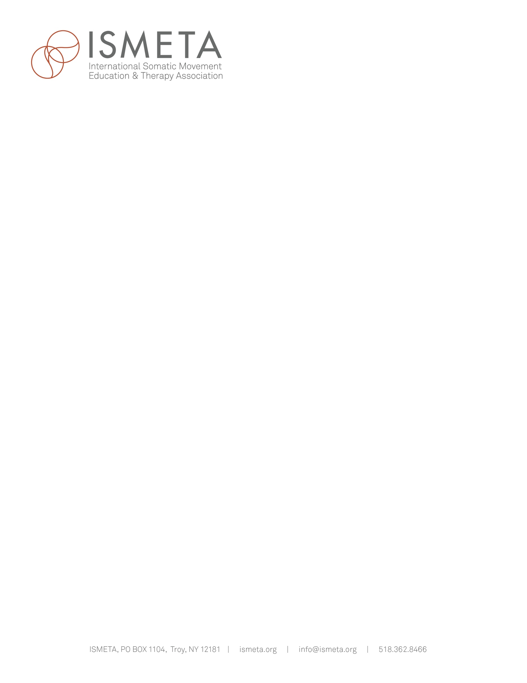

**2018 Approved Training Program Review Questionnaire**

ISMETA’s mission is to grow the profession of Somatic Movement Education and Therapy. The professional standards committee has done significant work to clarify our standards and raise our professional profile through updating the ATP and Independent Track applications.

As part of our ongoing quality improvement we are asking all training programs to share relevant programmatic and curricular updates. This will help us better understand how training programs are currently operating. Your detailed responses are greatly appreciated and valued as we move forward in our work to strengthen our field.

Name of Program: Click or tap here to enter text.

Person compiling information: Click or tap here to enter text.

Date: Click or tap here to enter text.

1. Please provide your current 500hrs training program curriculum. – Please provide an overview of what subjects, in what format, for how many hours.

Click or tap here to enter text.

1. Have you developed or changed your curriculum since the last Approved Training Program Review Questionnaire? Please give details.

Click or tap here to enter text.

1. Please submit a list of the current primary teaching staff for each program or course and a list of guest teachers and number of hours they teach.

Click or tap here to enter text.

1. The ISMETA Guidelines requires approved training programs include a two hour module of instruction about ISMETA and what it means to be a member of the profession of Somatic Movement Education and Therapy. Please see the “About ISMETA” Curriculum suggestions [here](https://ismeta.org/wp-content/uploads/2017/07/About-ISMETA-Curriculum_2017.pdf) and in the spirit of generosity please share one idea for how you deliver this content so we can add to the “About ISMETA” idea book.

Click or tap here to enter text.

1. Are you running a single training program or do you have multiple sites or programs? Are you initiating any new programs or curricular cycles that you would like ISMETA to know about?

Click or tap here to enter text.

1. Does your program provide/require continuing education? Please describe.

If yes is the continuing education approved by any other accrediting body. If so, what were your reasons for seeking outside approval.

Click or tap here to enter text.

1. The ISMETA requirements state *There must be grading and/or student*

*assessment policies in place.* Please provide a sample rubric for a module.

Click or tap here to enter text.

1. What are the key competencies or essential skills that your students need to demonstrate in order to graduate from your program? A competency is something a student knows, understands, or is able to do.

Click or tap here to enter text.

1. Please provide a sample Student Program Evaluation

Click or tap here to enter text.

1. How many current students are in the program now? Please also estimate number of graduates since the program began.

Click or tap here to enter text.

**Please note:** The 2019 Annual Approved Training Program Review Questionnaire will be distributed to all Approved Training Program (ATPs) in late October. Each program is required to complete the questionnaire and submit it along with any supporting documentation by January 15 of the following year in order to maintain their ATP status. To this end, many programs find that saving a copy of this document and revising it to include pertinent changes that have happened over the past year can be a great way to make the process both effective and efficient. We thank you in advance for your participation.