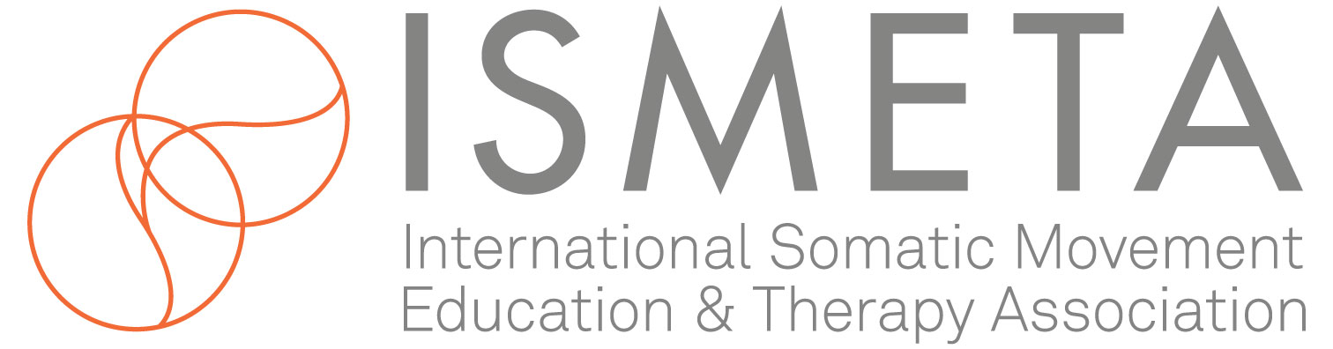

Dear Leadership Council Members,

Welcome to the ISMETA conference April 29 – May 1, 2022 Professional Pathways in Somatic Movement: Building Knowledge, Skills and Practices.

We are excited to offer this conference to the global Somatic movement community. This is a great opportunity to showcase ISMETA and the Leadership Council and to demonstrate to the world the high level of standards and competencies held by its members.

We would greatly appreciate your involvement in spreading the word about the conference and ask you to invite your networks.

Below is a sample letter we crafted for you to send out to your email lists to help make this a truly memorable event. Please:

- Copy, fill in and send out this email script. If you want to edit, please feel free.
- Check out the ISMETA Facebook Page and click the Event post saying “attending“ and click the Share Button and forward to those groups you have.

SAMPLE EMAIL SCRIPT / Facebook, Instagram (Edit as necessary) etc.

Hello ________,

As a member of the ISMETA Leadership Council, I am thrilled to invite you to participate in the upcoming online conference Professional Pathways in Somatic Movement: Building Knowledge, Skills and Practices, April 29th–May 1st, 2022.

This conference is organized by the International Somatic Movement Education and Therapy Association and will feature the work of ISMETA Approved Training Programs, Affiliated Professional Organizations, ISMETA Board Committees and Special Subject Experts.

Whether you are new to somatic movement or an established Registered Somatic Movement Educator or Therapist, this conference offers opportunities to explore and deepen your knowledge and skills in the profession. Attendees will explore and learn through in-depth embodied experiences, workshops, panel discussions and community conversations. The conference community will dive into our collective wisdom, nourish our creativity, and honor the tremendous growth of the Somatic Movement profession since ISMETA began in 1988.

If you are unable to attend the entire live event, you can relax with the knowledge that each conference session will be recorded, and the recording will be available for registrants to view for three months after the event.

I hope you will join me at this enriching conference.

Click here for more info and to sign up now!

Sign

* * * * * * * * * * * * * * * *

We are looking forward to sharing this conference experience with you!

With appreciation,
The ISMETA Events Committee

Here are some images for you to use to help spread the word.

