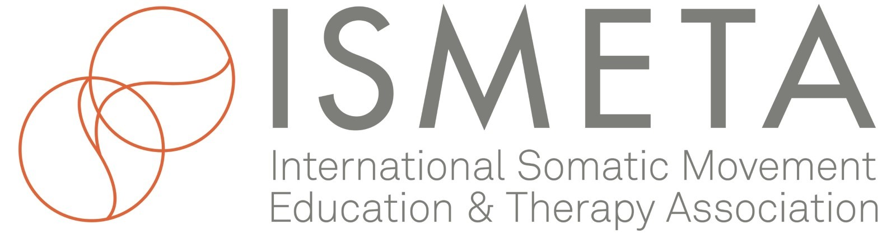

ISMETA Board Self-Evaluation and Reflection 2022
The ISMETA Board of Directors uses the expression “Board Culture” to describe our values as a group and the quality of how we work together. Each year the shape of the Board Culture re-forms, in response to the synergy of who is serving on the Board. This includes how we bring ourselves to our responsibility of service within each committee, and how through our committees we meet the needs of the organization. Our commitment to serve on the ISMETA Board of Directors reflects our love for somatic movement education and therapy and our desire to bring the profession to its highest level of integrity. Our personal and collective vitality depends on how well we hold the board’s overall functioning - and support ourselves and each other in the process. Our Board culture expresses a heart-centered leadership and service moving rhythmically as a complex system, no part greater than the whole.
Board Culture is held like a dynamic standard and it is important that we nurture it. Please consider these reflective self-evaluation questions as a support for our emerging collective shape, which is a process of working together, in the light of our mission and vision, and the current Values Clarification process. Simultaneously, we hope to uplift and nurture the attributes and uniqueness of each Board member and increase the vitality, the whole heart, of ISMETA’s leadership.
Let's each take a moment to consider the following questions as a personal reflection on your board service experience as we complete a cycle on October 31st. Thank you to Board member Gayatri Schriefer for having offered some additional self-reflection question, they have been integrated below.
The inner membrane: individual to board
- How have I felt serving ISMETA this past year/season? What have I learned? What questions have arisen?
- What do I want to generate in my life, or continue to generate, and how does that translate to ISMETA Board Service?
- How does my board service bring me joy and a sense of purpose?
- As a member of this working board, how do I consider myself as an integral part of the whole? Do I feel supported, and do I give support in my role as a board member? What can I do to elevate the way I interact and connect with / show up for / support other members on the board?
- Is my ISMETA work a priority in my life and do I have time for it?
- Am I communicating clearly, and in a timely manner with other members of the Board?
- Do I offer to take on tasks when the opportunity or the need is called for?
- What is my growing edge for developing my capacity for leadership?
- Am I showing up in the way I desire to, for myself and others, in my role serving on the board?
The outer membrane: Board to membership/world
- One of our main responsibilities as Board members is to represent our organization and its mission and vision. How comfortable, willing, and prepared do I feel as an ambassador for ISMETA? What do I need to improve this? What is standing in the way? Board Ambassador Sheet (click to view)
- As a board member, we are here to serve the membership. Do you have new ideas on how to improve our service particularly in the light of the Strategic Visioning Process?
Thank you for taking the time for this self-reflection. We trust this will inform your movement forward on the Board and strengthen the entire organism. If this reflection brings up questions or concerns about your board service please contact Marialuisa or Jane and schedule a time for a conversation.

With appreciation,
The Executive and Board Development Committees

