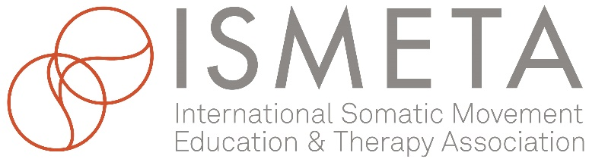

Application for ISMETA Associate Organizations

This membership category is open to any somatically oriented organization wishing to be a part of ISMETA and to connect to the worldwide Somatic Movement community. Training Programs that have less than 250 hours are well served in this membership category, as are regional societies of other larger international membership organizations and studio/centers offering Somatic Movement classes and sessions to the public.

Organization Name: Click here to enter text.
Website: Click here to enter text.
Email: Click here to enter text.
Address: Click here to enter text.
Phone: Click here to enter text.
Name of person completing this application: Click here to enter text.
Relationship to the organization: Click here to enter text.
Are you an individual ISMETA Member? Click here to enter text.

Please provide a brief overview of the organization: Please ensure your content is directly related to Somatic Movement Education and Therapy. Include your mission and vision in this overview. 300 word maximum. Click here to enter text.
How long has the organization been in existence? Click here to enter text.
Are the people involved with this organization ISMETA Professional Members? Click here to enter text.
Click here to enter text.
IV. POLICIES AND STANDARDS
ISMETA’s membership requires a high standard of professionalism by all members. The Pillars of the Profession; Scope of Practice, Core Competencies, Standards of Practice, and Code of Ethics, are established guidelines for the conduct of ALL ISMETA members. Please review these policies and standards from the viewpoint of your organization and attest to your alignment and intended compliance with these standards and Logo Usage Agreement, by checking the boxes below. Please note: Once accepted you will have access to the Logo Page to download the appropriate Logo.
- Pillars of the Profession: Review Document ☐ Applicant has read and agrees to comply
- Logo Usage Agreement: Review Document ☐ Applicant has read and agrees to comply
V. FINANCIAL REQUIREMENTS
Each Organization applying for recognition as an ISMETA Associate Organization agrees to pay a $35 no-refundable application fee and yearly dues of $125. Renewal notices are sent through email one month prior to due date and are expected prior to membership lapse.
Signed By: Name and Title.
Date: Click here to enter text.

